John Maloney

5 August, 2024

Guided Capstone Project Report: Big Mountain Resort

Big Mountain Resort, located in Montana, offers spectacular views and a wide range of skiing and snowboarding facilities. The resort attracts around 350,000 visitors annually, serviced by 11 lifts, 2 T-bars, and a magic carpet for beginners. The resort recently installed an additional chair lift, increasing their operating costs by $1,540,000 this season. The pricing strategy has been to charge above the market average, but there are concerns that this approach may not fully capitalize on the resort's facilities​. The goal was to develop a data-driven strategy to optimize ticket pricing, explore cost-reduction opportunities, and support decisions on future investments. The data included information from 330 comparable resorts in the US.

After cleaning and removing irrelevant and incomplete data, we explored trends across various ski resorts. We utilized Principal Component Analysis (PCA) to break down features into components, such as the variance of resorts per 100k capita. This approach allowed us to identify significant trends and visualize which features had higher PCA scores and greater variance from the average among all resorts. We then used the refined dataset to train a machine learning model. To achieve optimal performance, we built two separate models: a Linear Regression model and a Random Forest model. We refined the results further by using cross-validation to train on partitioned datasets and minimize the Mean Absolute Error (MAE). After comparing the results, we selected the best-performing model to calculate and visualize the expected ticket price for Big Mountain Resort in the context of the market.

The modeling of the data provided several interesting insights into potential investment strategies. We found that Big Mountain Resort's ticket price, at $81, is around the median compared to the pricing distribution across all resorts in the market (Figure A). Based on historical trends and all factors considered, the model suggests that the resort could charge up to $92.65. However, this estimate should be approached with caution, as the model's average prediction error is +/- $10.35 and is calibrated against all other resorts, regardless of whether they are overpriced or underpriced. In one scenario, the model predicted that a $0.54 increase in ticket prices could generate an additional $939,815 over the season. However, to cover the additional operating expenses from the new chair lift ($1.5M), alternative strategies such as increasing weekend ticket prices, offering season pass bundles, or providing special discounts to attract more visitors would need to be considered. The model requires more data to accurately estimate these outcomes. Another interesting finding was the correlation between ticket price and the number of runs closed. We discovered that while the value of lift tickets generally decreases with fewer open runs, closing up to five runs can result in some savings on upkeep with minimal impact on ticket value (Figure B).

In conclusion, there are numerous strategies that Big Mountain Resort can implement to optimize their operations and maximize revenue. The data-driven analysis revealed that the current ticket pricing is competitive within the market, yet there is potential to increase prices slightly without significant negative impacts. However, careful consideration must be given to the model's error margin and the market context. Additionally, alternative revenue strategies, such as adjusting weekend pricing or offering special deals, should be explored to offset the increased costs from recent infrastructure investments. The insights into the minimal impact of closing a few runs suggest that operational efficiencies can be achieved without compromising guest satisfaction. Moving forward, a continuous evaluation of data and market trends will be crucial in refining these strategies and ensuring the resort's financial health and customer experience.

Figure A:

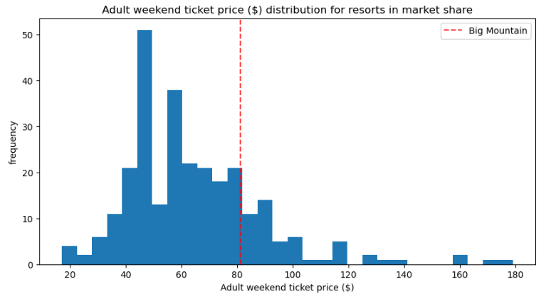

Figure B:

